Councillors:
Mr A Rue – Chair
Mrs D O’Doherty – Deputy Chair
Mrs J Dring
Mrs S Spry
Mr R Richards
Mrs N Taylor

North Kyme Parish Council

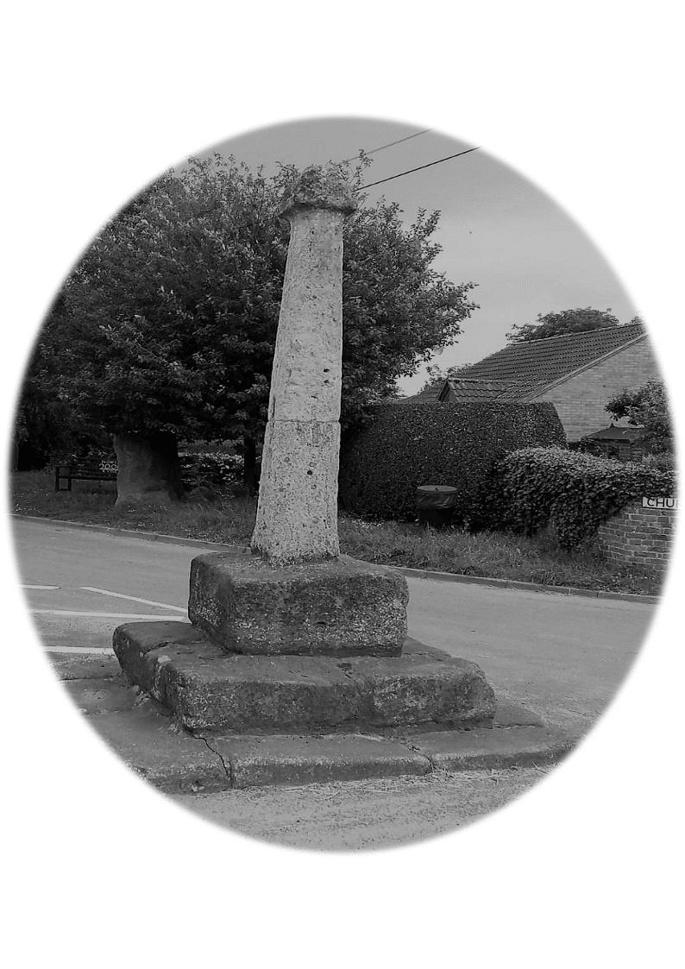

NOTICE OF MEETING OF NORTH KYME PARISH COUNCIL

Agenda

Dear Councillor,
You are hereby summoned to attend the next meeting of North Kyme Parish Council, which will be held North Kyme Village Hall on Wednesday 10th June 2026, commencing at 7.00 p.m. The business to be dealt with at the meeting is listed in the agenda.
There will be the opportunity for 10-minute Public Forum should anyone wish to address the council.
Signature…Carolyn Barber ……………. Clerk to the Council Date 3rd June 2026
- Chairs Welcome to the meeting.

- Apologies for absence and acceptance of any reasons given –

Cllr R Richards is unable to attend this meeting.

- Declarations of Interest-councillors must declare interests in planning or any items on the agenda.

- Updates from District Councillors: -

Cllr East is unable to make it this evening however he sent me an email with an update of what is happening with Causeway Road.

- Notes of the last meeting held on 13th May 2026 to be approved as the minutes.

- Updates from Councillors –
Weeds on Path
Taxi Drivers parking in Main Street upsetting residents.

- Report on matters outstanding –

- 009/08/2025 ~ Councillor Volunteers Service Need to decide what we would like doing.in the community.

- Financial Matters & Clerk’s Report

The gates have now been finished. I just wanted to say that Ellie came back on her own and finished the gates herself, I have written a thank you email.
Meeting dates for the next year - Only change to dates is the extra meeting date on the February Meeting.
Asset Register

- Bank Statement and Reconciliation Balance £ 12,381.09

- Expenses: -

Cllr G Everard – Fuel receipt for grass cutting. £35.38
LALC – Cilca Day Refreshments £18.00
Mileage & Training Hours £102.00 – Clerk.

Correspondence -,

- Planning – Ref 26/0530/PNAGR – Ivy House Farm 102 Main Street – Erection of open sided steel framed barn.

- Next Meeting 8th July 2026

Meeting Closed at

