Councillors:
Mr A Rue – Chair
Mrs S Spry – Deputy Chair
Mrs J Dring
Mr G Everard
Mrs D O’Doherty
Mr R Richards
Mrs N Taylor

North Kyme Parish Council

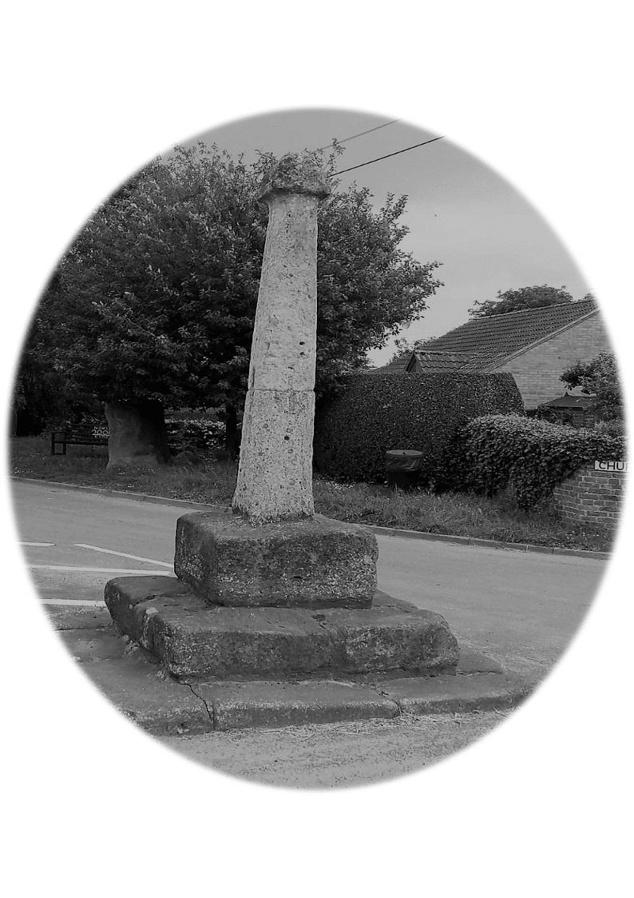

NOTICE OF MEETING OF NORTH KYME PARISH COUNCIL

Agenda

Dear Councillor,
You are hereby summoned to attend the next meeting of North Kyme Parish Council, which will be held North Kyme Village Hall on Wednesday 13th May 2026, commencing at 7.00 p.m. The business to be dealt with at the meeting is listed in the agenda.
There will be the opportunity for 10-minute Public Forum should anyone wish to address the council.
Signature…Carolyn Barber ……………. Clerk to the Council Date 6th May 2026
- Chairs Welcome to the meeting.
- Apologies for absence and acceptance of any reasons given -
- Declarations of Interest-councillors must declare interests in planning or any items on the agenda.
- Updates from District Councillors: -
Causeway Road –
- Notes of the last meeting held on 15th April 2026 to be approved as the minutes.
- Updates from Councillors –

- Mediation –
- Team Work –
- Good Councillors Guide –
- Civility and Respect –
- Emergency Facilities –

- Community Lead – Spear Head Steering Group –
- Do we expand on the Christmas Light service?
- Storage facilities for garden equipment do we need to upgrade this?

- Report on matters outstanding –

009/08/2025 ~ Councillor Volunteers Service

- Financial Matters & Clerk’s Report:

Equipment for Volunteers has been purchased

- Bank Statement and Reconciliation Balance
Bank Reconciliation £

Carolyn’s CILCA and South Kyme

LALC Summer Conference Alan and Clerk to attend.

Staff Sub Committee

Finance Sub Committee

Meeting Dates for the next year

Other Items South Kyme are not paying half of the mobile contract

To review and agree the 2025-26 Certificate of Exemption for the Annual Govern ance and Accountability Return (AGAR).

To present the Budget Monitoring Report and approve the Bank Reconciliation for the current financial period.

To authorise the signing of Accounts for Payment for the current financial period.

- Expenses: -

Internal Audit – Alison Bourne £30
Cllr G Everard – Fuel receipt for strimmer £5.00
LALC £ hours with Webmaster already authorised £72.00
Cllr A Whittle - Paint and Strimmer £ Strimmer is £50 paint is £
Richard Tonge £29 for flower boxes
Arnold Baker Book - £75.00 for the council to pay the clerk will pay the rest out of her own pocket. Book with postage came to £149.99. Council to raise invoice to clerk for the rest.
Clerk – Paint brushes paint pots and wire brushes £ 53.80 on the council debit card.
Clerk - End of year extra hours and travel and postage £ 119.41

- Correspondence –
Zenrith insurance sent a payment receipt £ 500
Bus Shelter Grant – require full costings and quotes

- Planning – PLANNING REFERENCE: 25/0431/CCC
LCC REFERENCE: PL/0016/25.
Biogas Plant.
- Next Meeting 10th June 2026

Meeting Closed at

